**CubeSat**

Cubesatellite is a mini satellite that follows standarized shape and sizes.

Each CubeSat unit is called 1U, which means it is a cube of 10 cm × 10 cm × 10 cm, and typically weighs up to 1.33 kg.

CubeSats can be made in larger sizes by combining these standard units:

1U = 10×10×10 cm

2U = 20×10×10 cm

3U = 30×10×10 cm

6U = 20×10×30 cm

It contains different types of electronics

1.On board Computer-processes data

2.Power System- solar panel, batteries

3. Payload-camera,sensor

4.Structure

CubeSats are usually launched as “secondary payloads” along with bigger satellites.

CubeSats are transforming space by making it affordable, accessible, and innovative.

The main purpose of the cubeSats is to have payload,it can have different types of sensors,camera etc.

It is lightweight and strong

Usually material used as a cube sat is aluminium as it is light weight and strong.

CubeSat is made like that it can withstand launch vibration and G forces

They are small and cheap compared to big satellites.

Easy to build for universities, companies, and even small countries.

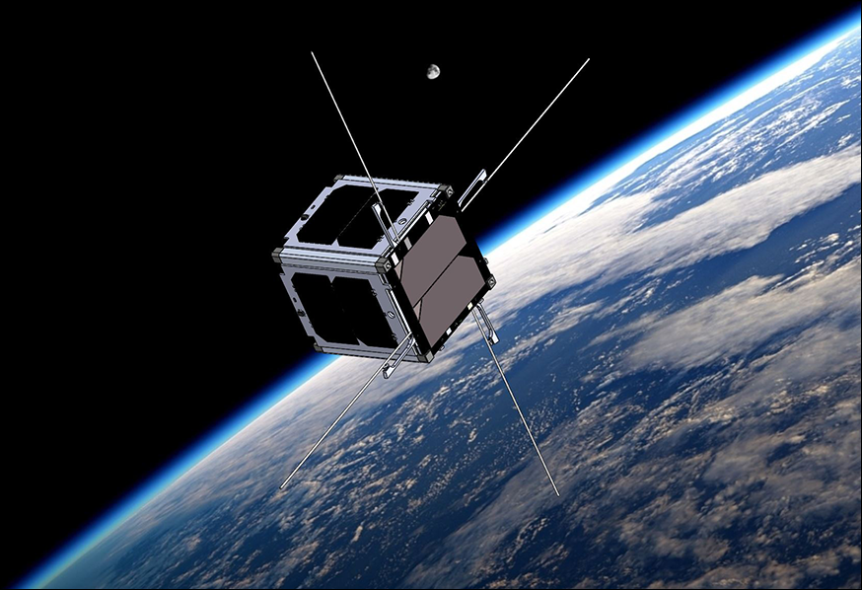

*A CubeSat developed by BYU students, demonstrating its compact size.*

**CAN SAT**

A CanSat is a small satellite

It is not an actual satellite but a miniature simulation used mainly for education and experiments.

Usually launched on rockets, balloons, or drones, they fall back to Earth while collecting and sending data.

We use cansat so that we learn satellite technology affordably.

We can also design sensors ,collect data from cansat.

We can fit many things inside cansat-

1.Sensors.

2.Microcontroller or small computer.

3.Radio transmitter to send data.

4.Battery power.

5.Parachute for safe landing.

How it works-

1.It’s launched high into the atmosphere.

2.During descent, it records environmental data.

3.Sends data to the ground station.

4.Lands safely with a parachute**.**

